

Prepared by:

**Gerber Technology**

**YuniquePLM**

**System Overview**

YuniquePLMTM Overview

YuniquePLM™ is a fashion-specific, web-based application built on the Microsoft .NET platform. It is configured to meet their specific business needs for each company that implements the application. This documentation will focus on the general concept of each module of the YuniquePLM™ software application.

Since YuniquePLM™ is a web-based application it will successfully run on both Windows PC and Macintosh, using each computer’s respective, native browser.

Macintosh – Safari 3.1 or higher

Windows – Internet Explorer 6 or higher

YuniquePLM™ requires 3 different servers in order to run. All server platforms must run on a SQL 2005 or higher platform. The purpose of each server is as follows:

Server 1 runs the YuniquePLM™ software application

Server 2 is a file server that holds all of the images imported into the YuniquePLM™ system

Server 3 is the database server.

Logging In

1. Open your computer’s native web browser.
2. Go to the YuniquePLM™TM log in page.

**Note:** Because YuniquePLM™TM is customized for each client, the specific web address for the YuniquePLM™TM log in page will vary.

1. Enter your *User Name* and *Password*. The password should contain letters, numbers, and special characters.

Click the **Login** button which will then take you to the Desktop, which is the main window of the YuniquePLM™ system. This is the window that is uses to access all other YuniquePLM™ folders. Each of these folders will open in a separate window unless options are selected for window tabbing.

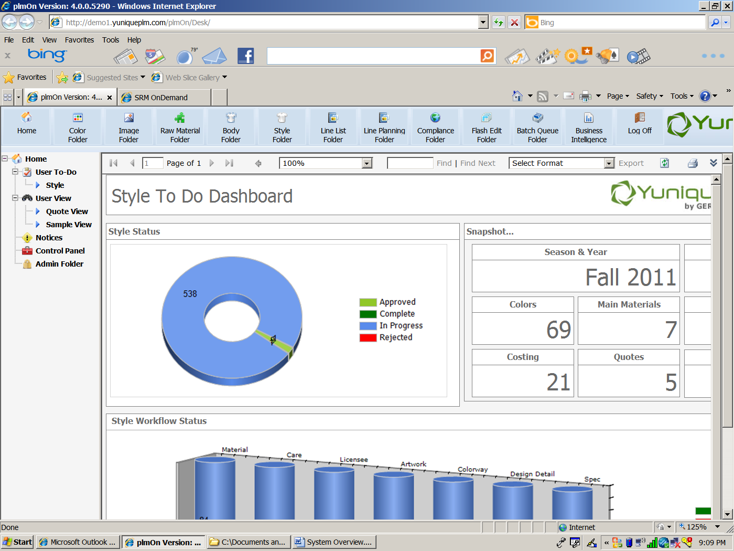

To log off the system, simply click on the Log Off button on the upper right had corner.



Autopost back for searches

Configurable searches